MSU-WIPRO STEM & LEADERSHIP FELLOWSHIP PROGRAM
Name: Ajay Kalra
Assignment: Dream IT project report Phase 2
Instructor: Dr. Punya Mishra
Date Submitted: December 1, 2014

Being a math educator for last 19 years, I believe math is a language and students need to be confident in using math vocabulary to communicate in math and reflect their understanding of concepts and skills.
I spend a good chunk of class time making sure students understand math vocabulary and are able to provide example examples , application and non- examples of math terms.
I think Frayer’s model is a pretty good graphic organizer which helps students to define, exemplify, apply the math vocabulary and thereby enhance their understanding of math concepts.
Here are some of the artifact of interactive notebook (students created with support of teacher) entries over relations, functions, and slope from my Algebra 1 class. I started out the unit with miniature Frayer Models. My favorite part is the example and non-example boxes. The more Frayer Models we complete, the more my students want to create their own examples and non-examples. Their thought processes are slowly changing. They are starting to process the material and make it their own before I prompt them to.
My students like to pay Jeopardy game on math topic. To get feedback on understanding of students I use Jeopardy game as an exit ticket which helps students to communicate their understanding of concepts in an interactive and keep them engaged.

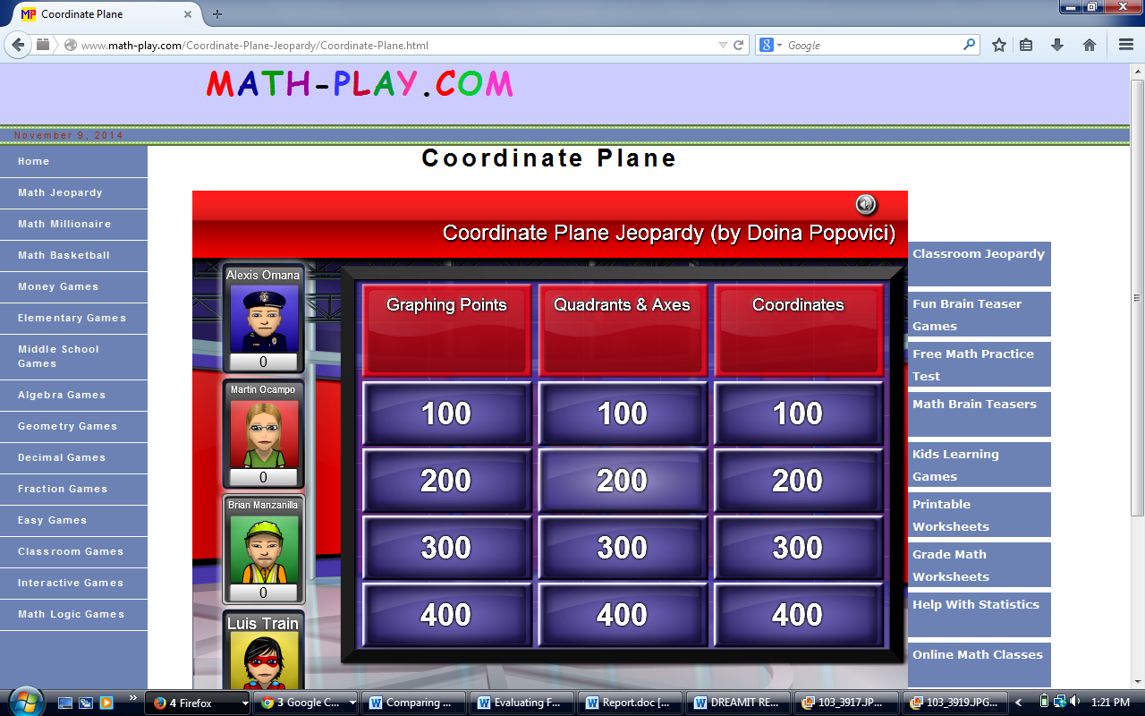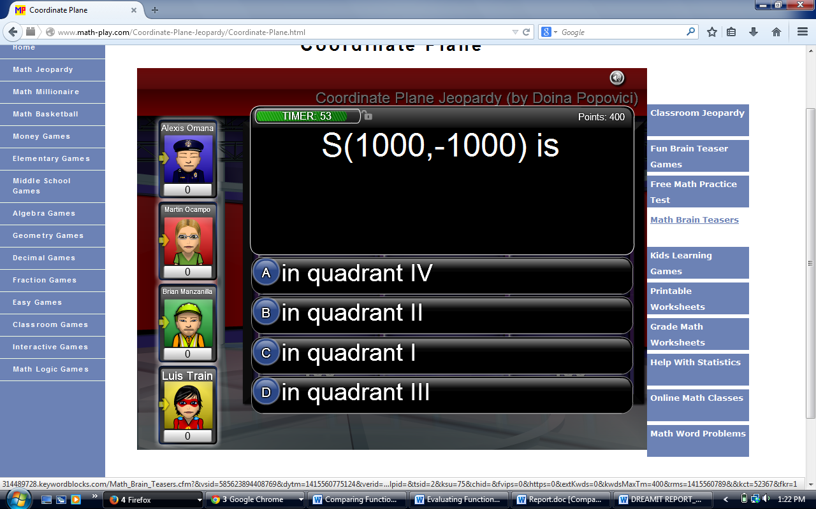
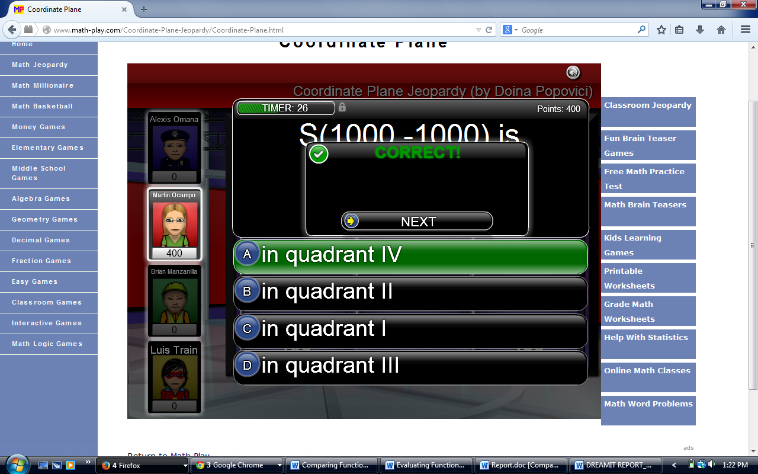
For example, recently we completed a Frayer Model on slope of line and y-intercept. In the example box, I instructed my students to draw a linear graph and mark the y-intercept using a colored pencil. Before I could give them instructions for the non-example box, I had students giving suggestions left and right. Some wanted to mark the x-intercept. Others wanted to mark a point that was not even on the line. Still another said we could mark any point that was not the y-intercept. At the beginning of the year, my students didn't even know what a non-example was and why need it. Now, they realize that not only examples, non-examples also help to understand concept and retain it. I feel that one’s students are equipped with math terms and vocabulary they can talk more about mathematics and communicate their understandings.
Since I have am teaching and facilitating self-contained class of diverse learners, my biggest challenge was to make students learn, think and finally talk mathematics. I created and selected activities which were not only engaging but engaging students intellectually.
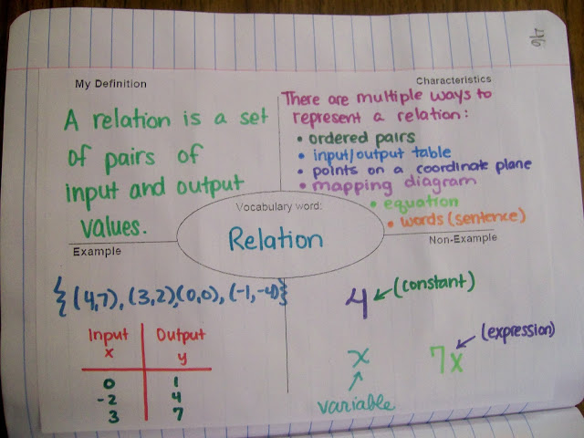
Many of my students think each subject as separate entity and never were asked to apply concept learned in one subject to different subject .I helped my students to find speed of an object using distance –time graphs by applying concepts of slope thereby making the connection between science and math in STEM.
I covered many real-life applications of slope, including roofs, roads, handicap ramps etc. and asked students to visit math websites and read about each of these, as well as look at pictures. We also used tape measure to find slopes of staircase and wheel chair ramp to bring in engineering(E) part of STEM.
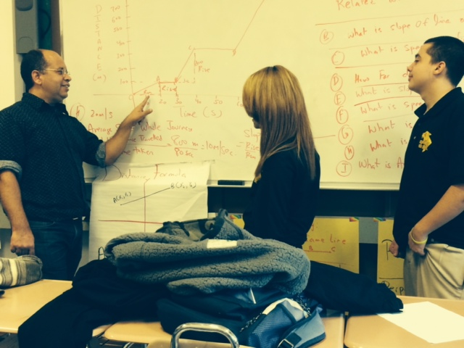

Example of slides used in PPT
